**Total price per customer**

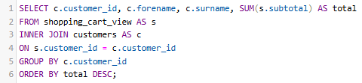

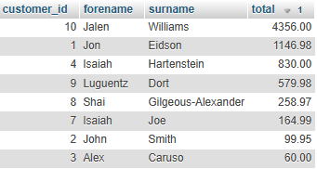

**Show customers with more than 100€ in the shopping cart**

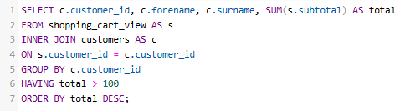

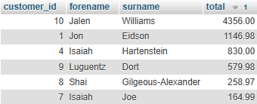

**Total number of items per customer**

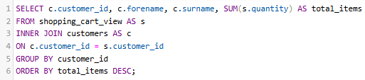

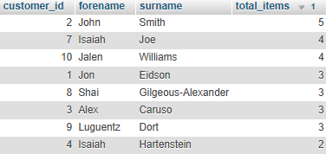

**Average number of items per each customer**

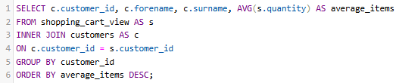

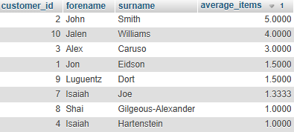

**Average number of items that customers put in the shopping cart**





**Total sales per year**





**Total sales per year & quarter**

**Total sales per order**

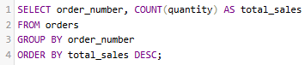

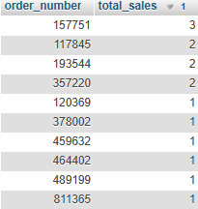

**Total units sold per product and benefits**

